**Research on Image Process (Deep Corn)**

**Contents**

**S.No Chapters**

1. **Introduction**
2. **Technology Prerequisites**
3. **History of Image Processing**
4. **Data Sets**
5. **Summary**

**CHAPTER-1: INTRODUCTION**

The corn image processing was done on various parameters like the depth of the kernels and the size of the kernel, the diseases of the corn leaves etc.

The image processing on the corn kernels length, width of the ear i.e. ear length, ear width, how many kernels for the one ear of corn.

Basically, we go through into manually to count and pick the best corn by manually testing and depending on the more man power is required. So for that we need to decrease the time on the manual approach, we use deep learning technology to overcome this problem.

This work presents plant disease detection using an image processing technique for an automated vision system used in the agricultural field.

It is very difficult for a farmer to identified various disease in plants. The estimated annual crop losses due to plant disease at the worldwide is $60 Billions. The traditional tools and techniques are not very useful since it takes lots of time and manual work

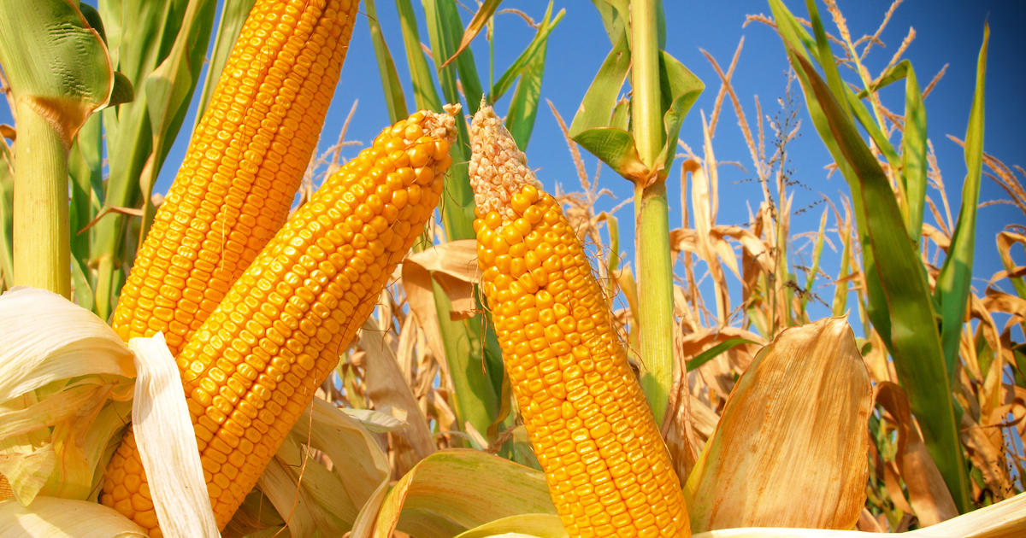

**CHAPTER-2: Technology Prerequisites**

Previous studies proposed deep learning based methods to accurately predict corn yield based on factors such as genotype, weather, soil, but none of these studies are considered as the High Through-put Image on commercial corn.

There are various technologies are included in the deep learning which includes Machine learning with appropriate algorithms, and some of the [image processing](https://www.sciencedirect.com/science/article/pii/S2214317321000226) units are done on corn fields.

Some of the most popular software’s are used in the image processing like MATLAB.

Deep learning is built on a combination of [**machine learning algorithms**](https://registry.opendata.aws/intelinair_corn_kernel_counting/) that use multiple nonlinear transformations to model high-level abstractions in data.

**Recurrent neural network** (RNN) and **convolutional neural network** (CNN) are two standard deep learning networks used in agriculture.

**Convolutional Neural Network (CNN)**

A CNN is a deep learning algorithm composed of multiple convolutional layers, pooling layers, and fully connected layers.

It is a multi-layer neural network based on the animal visual cortex. CNNs are mainly used for **image processing** and handwritten character recognition.

CNNs have been used for image classification, object detection, fragmentation of images, voice recognition, text and video processing, and medical image analysis, among other functions.

A CNN architecture typically consists of convolutional, pooling, and fully connected layers.

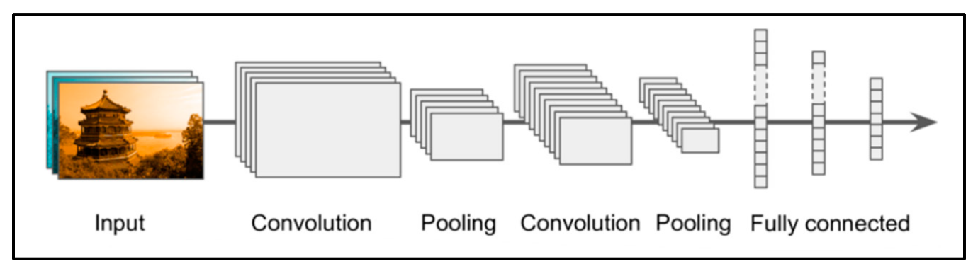

Figure 1. CNN architecture.

**Recurrent Neural Network (RNN)**

An RNN is a neural sequence model that performs exceptionally well on crucial tasks such as language modelling, speech recognition, and machine translation.

RNNs, as opposed to traditional neural networks, take advantage of the network’s sequential information; this attribute is critical in many applications where the structure inherent in the data sequence contains valuable information.

**Pixofarm**

[Pixofarm](https://www.pixofarm.com/blog/what-does-image-processing-have-to-do-with-precision-agriculture#:~:text=The%20first%20one%20is%20crop,nutrient%20deficiencies%20and%20plant%20content.) is a solution based on image processing, where the source of data is a number of pictures of fruits taken directly in the orchard throughout the entire season. Aimed to provide data about the growth of fruits and predicted information on the outcome of the season, Pixofarm brings this technology to an area at the beginning of its development, meaning yield monitoring.

While more developed solutions are about pest detection, quality inspection, and crop management mainly for extensive crops, Pixofarm is focused on horticulture. The technology is trained to precisely measure fruit sizes just from a bunch of pictures taken with almost any phone since it is dynamically adaptable based on the phone hardware characteristics (especially the camera and lens specifications).

**Features of Pixofarm**

* Object detection machine vision: Pixofarm can recognize the apple and focus on its shape.
* Fast and accurate segmentation using watershed, and computational geometry algorithms.
* Leaf tolerance and detection stability in outdoor noisy conditions using adaptive filters.
* Color independent image processing using algorithms and geometry tools.
* Stereo vision and point cloud analysis for 3D reconstruction and better sizing.

**Mobile Lens**

The generation was changed, we need to get the instant results from the material’s what we excepted.

So for that we need to use a [mobile](https://www.mdpi.com/2073-4395/10/6/855) to scan the entire ear of the corn it should display the results of that corn.

The mobile tracking of the [diseases](https://viso.ai/applications/computer-vision-in-agriculture/) for the leaves, counting of the kernels are done by image processing.

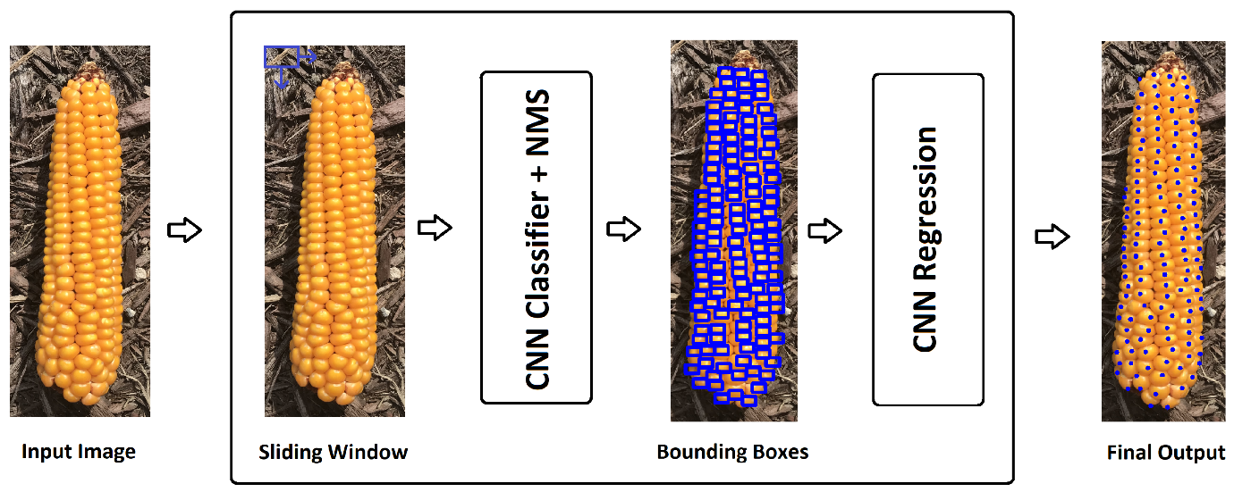

**CHAPTER-3: History of Image Processing**

[Image processing](https://www.sciencedirect.com/science/article/abs/pii/S0950705121001374) in agriculture has gained significant attention in recent years due to advancements in computer vision, machine learning. These techniques have the potential to revolutionize farming practices by providing real-time monitoring and analysis of crops, leading to improved productivity and resource management.

When it comes to corn, image processing techniques have been applied in various areas, including:

**Crop Monitoring:**

Images captured by drones, satellites, or ground-based cameras are used to monitor the growth and development of corn crops. These images can provide valuable insights into plant height, leaf area, biomass, and overall crop health. By analyzing these images over time, farmers can track crop growth stages, identify areas of concern, and make informed decisions regarding irrigation, fertilization, and pest control.

**Disease Detection:**

Image processing algorithms can be used to detect diseases or pests affecting corn crops. By analyzing the color, texture, and shape of corn leaves or ears, these algorithms can identify the presence of diseases such as common rust, gray leaf spot, or stalk rot. Early detection of diseases allows farmers to take prompt action, such as targeted pesticide application or crop rotation, to prevent the spread of infections and minimize crop losses.

**Weed Identification and Management:**

Image processing techniques can help identify and distinguish between corn plants and weeds in fields. By analyzing images, computer vision algorithms can classify and locate weeds, enabling targeted herbicide application. This reduces the amount of herbicides needed and minimizes their impact on the environment, leading to more sustainable weed management practices.

**Yield Estimation:**

Image processing methods can also be utilized to estimate corn yield. By analyzing images of corn ears, algorithms can count the number of kernels, estimate their size and weight, and provide an approximate yield prediction. This information is valuable for farmers in planning harvest logistics, optimizing storage, and making informed marketing decisions.

**Harvest Automation:**

Advanced image processing technologies are being explored to automate corn harvesting processes. Computer vision algorithms can identify and locate mature corn cobs, guiding robotic systems to efficiently harvest crops. This technology has the potential to reduce labor costs, increase harvesting speed, and minimize post-harvest losses.

A robust on-ear kernel counting that is invariant to image scale variation, ear shape, size, orientation, lighting conditions, and color.

A new deep learning architecture that is superior to commonly used crowd counting models.

A kernel counting dataset to benchmark our proposed method.

**CHAPTER-4: DATASETS**

**Dataset:**

The [dataset](https://naagar.github.io/cornseedsdataset/) is highly varied in a number of manners including image [size](https://www.researchgate.net/figure/Modeling-structure-of-our-proposed-corn-kernel-detection-method-A-detailed-description_fig2_341307799), resolution, number of ears present, total number of kernels present, background, lighting, corn variety, image type (i.e., photograph vs. cartoon), amount of zoom, etc. This is in stark contrast to the datasets used for many corn kernel counting applications which are restricted to the domain expected at inference: an outdoor image of a single ear of corn, belonging to a single (or limited set) corn variety, vertically oriented, at a roughly standardized size, at a standardized resolution, and with minimal shadowing or occlusions.

We need to have so many bulk images of corn in various conditions like 360 degree images, leafs images, the colour of the silk hair on the top of corn and also the covered of the corn is colour should be also one of the parameter.

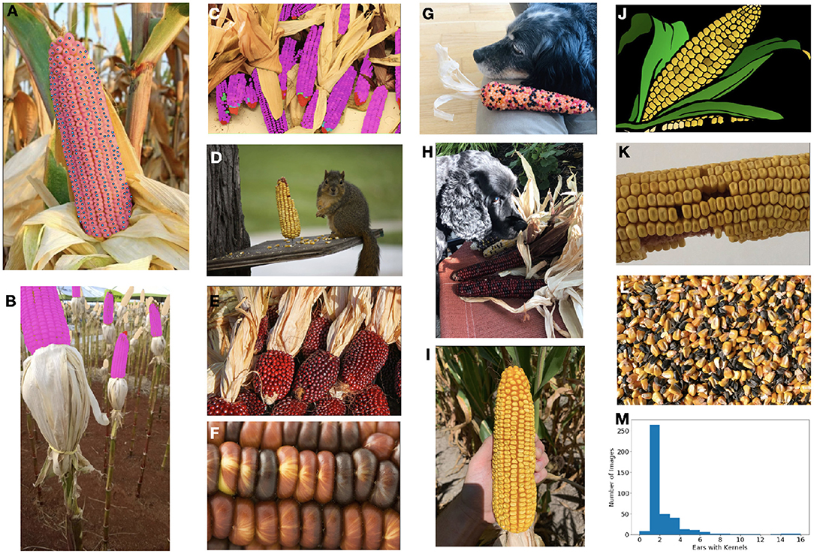

FIGURE. The ultimate goal of this model is count and localize the healthy kernels on ears of corn.

All the images are stored in the jpg format and it should be tested in various parameters.

**CHAPTER-5: Summary**

Coming to Overall summary on the deep corn by the end of 2021 there was so many researches are done by finding the disease of the leaves, counting of kernels, finding colour of the kernel.

But there is no research or any testing stage implemented on the finding of the ear length, ear height, and kernel counting which is not picked from the corn tree.

Still there was testing going on the counting of kernel, diseases etc.